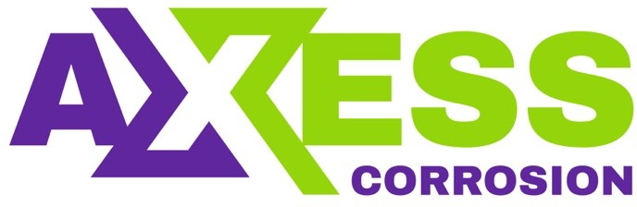
Daily Progress Report

Installation / Location | Halul Island
Subject | Corrosion Monitoring Activities
Contract Number | LC241047A0
Assigned Axess Representatives | Stuart Dunthorne
Date of Issue | 22-07-2025

Activities Summary
Today’s activities mainly involved final servicing and testing of the retrieval equipment. The 2 Service Valves tat were used on PS-3 were fully stripped, cleaned and rebuilt. Upon completion of valve servicing all the kit was pressure testing using the old Enerpac pump. All the retrieval tools and valves passed pressure tests ok so everything is ready for the next campaign.
All the other boxes that came back from PS-3 (parts, consumables, hand tools etc etc) were put back into the relevant places and the workshop was given a good tidy up.

Time | Activities
06:00 to 11:00 | Strip down, clean & rebuild 2 x Service Valves. Empty the rest of boxes that returned from PS3
11:00 to 12:00 | Lunch
12:00 to 18:00 | Pressure test 3 x Retrieval Tools & 2 x Service Valves. Tidy workshop.

Observations & Recommendations
None

24 Hour Lookahead
The plan for Wednesday 23rd July is to return to Doha in the morning.

Stuart Dunthorne – Axess-Corrosion. – sdunthorne@axess.energy

